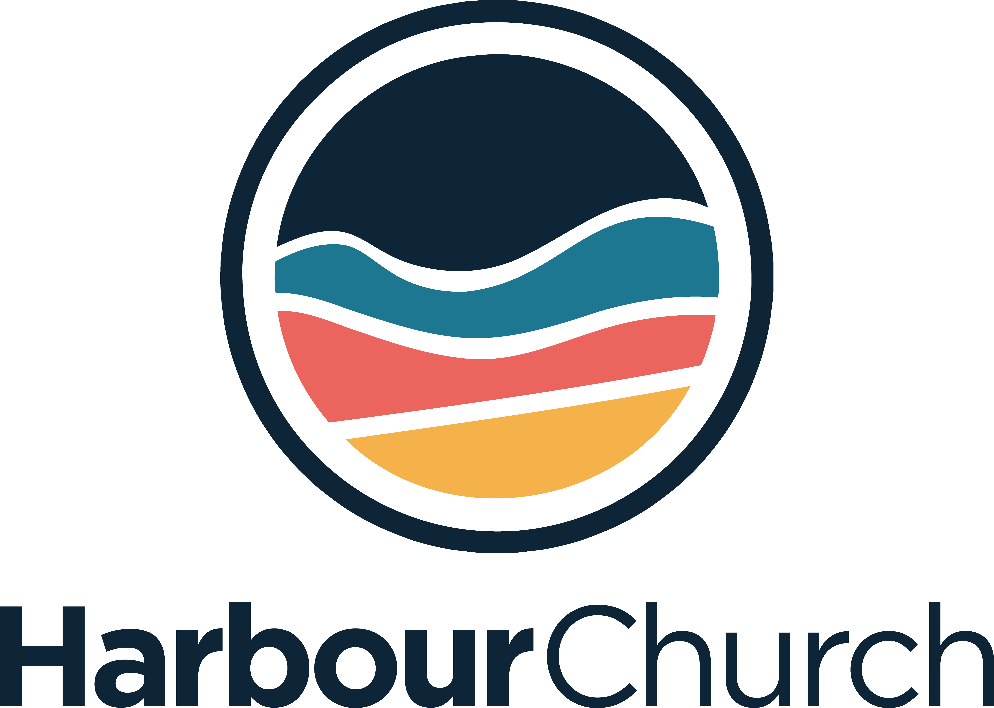

Ministry Development Year 24-25 Application Form

Thank you so much for your interested in the MDY. We’re so excited to help you discern your sense of calling to play your part in Harbour’s vision.

Please fill out the form below and forward to hello@harbourchurchuk.org

Name:
Email:
Phone:

Tell us about your journey of faith so far:

What is your current involvement at your church?

Why have you chosen to apply to the Ministry & Development Year at Harbour Church?

Are you interested in serving in a particular area of church life? Tell us about any relevant experience you have.

Is there anything else you feel is relevant to your application that you would like to tell us?

Reference 1
Name:
Email:
Phone:
Relationship:

Reference 2
Name:
Email:
Phone:
Relationship:

If you need any further information or have any questions, please contact hello@harbourchurchuk.org

